CERN in Sarajevo: invitation for the exhibition „Art@CMS” by Michael Hoch (CERN) and “Physics of CERN” (CERN)
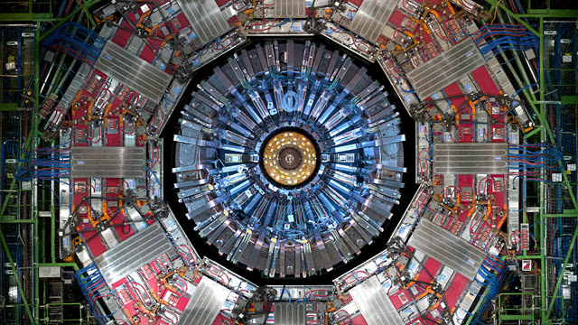

Society for science advocacy „Science and the World“
1st October 2018
Muse Ćazima Ćatića 31

Dear Sir or Madam
It is a privilege to invite You to participate at the Opening ceremony of exhibition „Art@CMS“, organized by representatives of CERN and Society for science advocacy „Science and the world“. This event will be held at the Academy of Fine arts (Akademija likovnih umjetnosti-ALU), Obala Maka Dizdara 3 on 16th October 2018. The event will begin at 18:00 pm.
Science and science literacy are among the pillars of democratic society and we recognize the importance of these components for the future of Bosnian society and its fragile democracy.
We at Society for science advocacy „Science and the World“ would appreciate Your participation.

Yours faithfully,
Nenad Tanović, PhD, President of the Society for science advocacy „Science and the world“
Jelena Kalinić, Vice-president
Bojan Šošić, Secretary

